Stolle US-14/Ankaro UKS-14, original

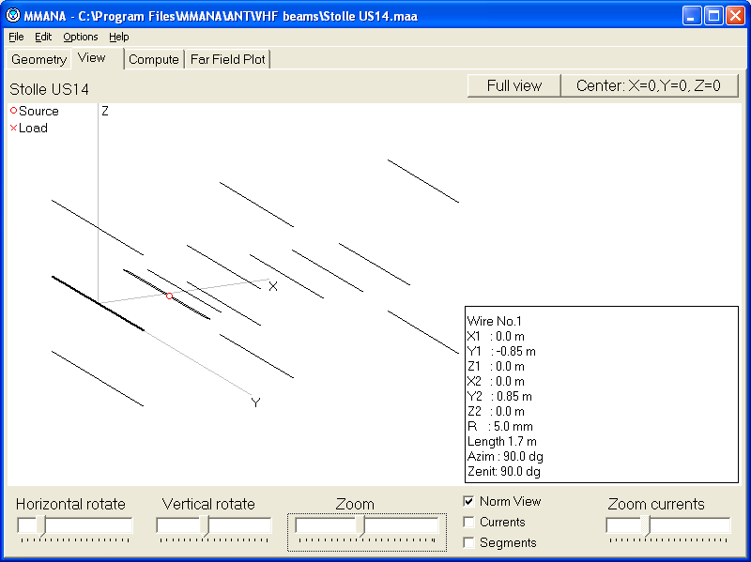

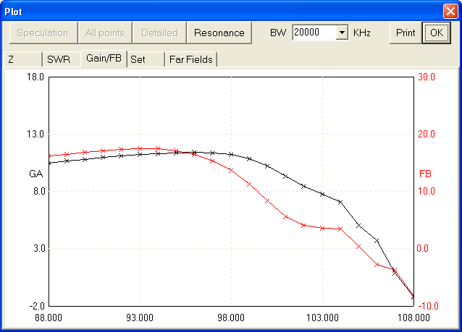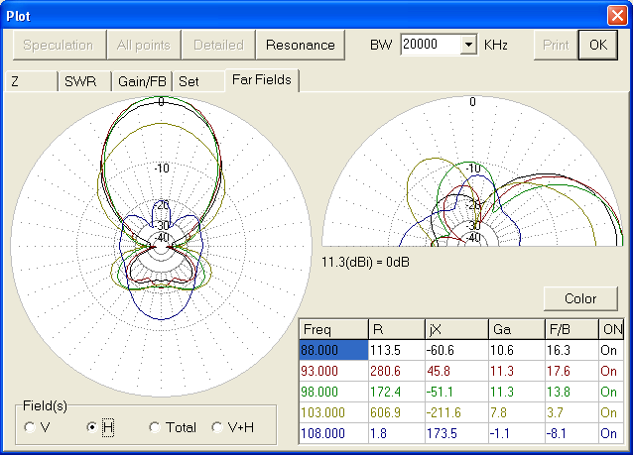
Gain and F/B Patterns

Modified

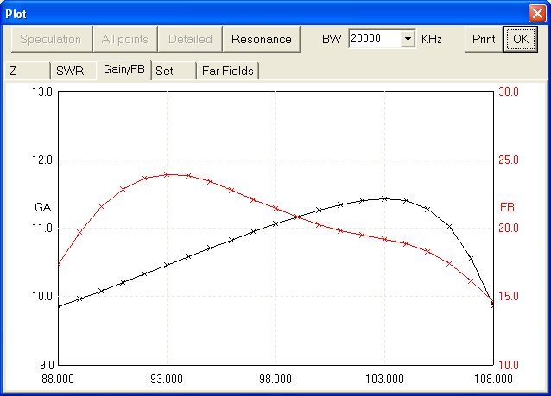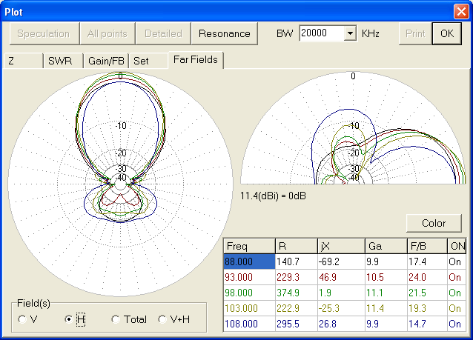
Gain, now reaching 108 MHz Patterns

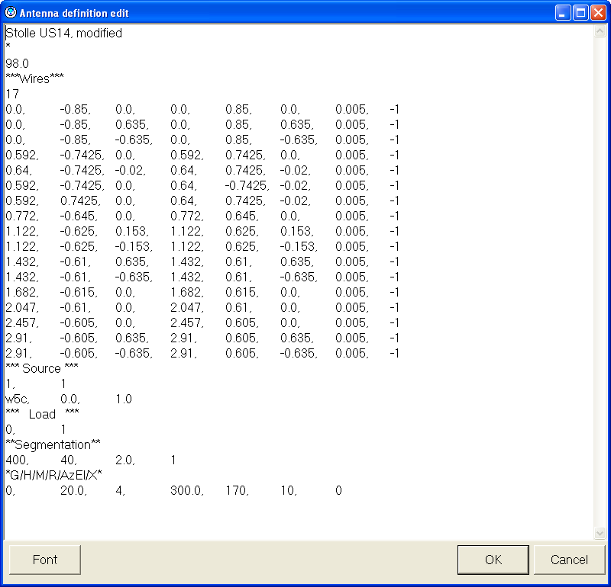
Dimensions after modification as noted in MMANA

Director length changes:
Director 1: 1.29m
Directors 2 and 3: 1.25m
Directors 4 and 5: 1.22m
Director 6: 1.23m
Director 7: 1.22m
Director 8: 1.21m
Directors 9 and 10: 1.21m

Peter Körner
Lund
Sweden

